Exercise 15
- List all employee ids and birth dates who were born before 1965.
Answer: SELECT emp_id, birth_date
FROM employee_data
WHERE birth_date < '1965-01-01';
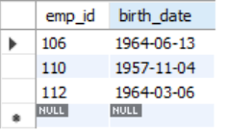

- Display ids and birth dates of employees born in and between 1970 and 1972. (This is tricky... you need to give it a little thought)
Answer: SELECT emp_id, birth_date
FROM employee_data
WHERE birth_date BETWEEN '1970-01-01' AND '1972-12-31';
